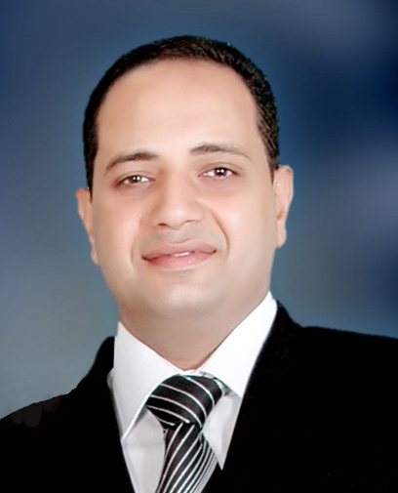
C- v

• • - Name : - Said Mostafa Mohammad Hamid Youssef.
• • - Date of Birth: - 16/3/1977 Assiut
• • - Current job: - Lecturer in Art Education Department, Faculty of Specific Education, Assiut University Specialty Woodwork
• • - Address: - Assiut Al Khulafaa Street
• • - Phone: 01091027875
• •Telephone: - 0882311540
• • E- mail:- E-mail: - said.mostafa21@yahoo.com
• • - Grades:

• • - Bachelor of Arts and Education University Assiut in 2000
• • - Diploma Tkmleily Faculty of Art Education, Helwan University, 2006 grade of Excellent.
• • - Diploma biennial Faculty of Art Education, Helwan University, 2006 - 2008 Bkadir Aa very well.
• • - Master of Art Education, titled: - innovative applications for covering inspired by the wooden shavings houses antiquities Assiut 2010.
• • - Pre doctor Faculty of Specific Education Assiut University 2011 estimate Aa very good
• •- PhD in Art Education entitled (interactive art as an input to create a wooden busy) Assiut University
• •- Fine Artists Association.
• • − Member of the Association of graduates of the Faculty of Art Education.
• •- Computer courses in: PHOTO SHOP PHOTO SHOP –AutoCAD AutoCAD - ICDL
• • − English: certificate TOFEL. ELPT
• • - Participate in the implementation and supervision of Wall Faculty of Specific Education with the fourth year students rule the draft.
• • - Supervision of field education groups both the third and fourth divisions in foreign schools.
• • - Supervision of student activities at the Faculty of Specific Education, Assiut University.
• • - Participate in effective Ollliopil Golden Assiut University In period 4/11 to 25/11/2007.
• •- Do taught to the children of faculty members to work drawing and artistic works June 2003, 2004, 2005.
• • - Participation research in the first conference of young researchers entitled (Fine technical bases and wooden frames in a selection of ancient and modern art and to use them in the production of contemporary wooden busy).
• •. Participate in the preparation of the scientific conferences and festivals within the college.
• •. Participate in the implementation of the wall within the college March 2008.
• • Participate in the first International Forum for Fine Arts (South .. South dialogue), which was held at the headquarters of Assiut University in the period from 16 - 18 November 2007 . .
• • Participate in the implementation of the wall of mosaic at the entrance of the university city to city students at Assiut University entitled dream of young girls.
• • Participate in the implementation of the mosaic wall at the Institute of South Egypt Cancer Assiut University under the title of ancient and modern medicine July 2008.
• • Participate in the activities of the second session specialized colleges of education quality and fine arts at Egyptian universities during the period 13/2 to 16/2/2010.
• • Participate in the Second International Forum for Fine Arts (South dialogue .. South) from 1/11 to 11/03/2010 under the title Art between material values ​​and spirituality.
• •. Participate in the art exhibit numbers in the eighteenth festival graduates - May 2010/2011.
• • Participate in the preparation and organization of the Sixth International Conference (Environment and Development in the Arab world) in the period 24 - 26 March 2012 primarily at the University of Assiut.
• • December under the title Digital Arts in the twenty-first century and its impact on the concept of art
- Exhibitions: -
• • All exhibitions held at the University of Assiut from 2006/2010.
• • Acquainted with the artistic movement of domestic and international.
• • Participate in the palaces of culture in Assiut.
• • Beauty participate in maintaining multiple ores.

